

Configure Application Insights and App Service Logs for a Web App

Understand the scenario

You are an Azure® developer. You need to create and deploy an Azure web app that includes Application Insights and App Service logs. First, you will create a web app, and then you will deploy the source code for the web app. Next, you will enable Application Insights for monitoring. Finally, you will enable App Service logs for auditing and debugging.

Understand your environment

You will be using an Azure resource group named corp-datalod26435405 that contains a Log Analytics workspace.

# **Create an Azure web app**

* Sign in to the Azure portal

Select the Copy to clipboard icon to copy the text string to the clipboard.

A cloud slice is a subset of an Azure subscription that has been assigned to a user account that was provisioned for you for the duration of this challenge lab. A cloud slice provides temporary access to a subset of resources available in a cloud subscription so that you can learn the concepts in this challenge lab without having to configure your own subscription.

A cloud slice has restrictions on the types of administrative activities that are allowed. Please follow the instructions carefully, especially with regard to names and other configuration details.

* Create an Azure web app by using the values in the following table. For any property that is not specified, use the default value.

| **Property** | **Value** |
| --- | --- |
| Resource Group | **corp-datalod26435405** |
| Name | wa26435405 |
| Publish | **Code** |
| Runtime stack | **ASP.NET V4.8** or the latest version that is not preview or early access |
| Region | **East US** |
| Windows Plan (East US) | AppPlan1 |
| Sku and size | **Standard S1** |
| Continuous deployment | **Disable** |
| Enable network injection | **Off** |
| Enable Application Insights | **No** |

* Expand this hint for guidance on creating an Azure web app.
  + On the Azure portal home page, select **Create a resource**.
  + In the Popular Azure services list, select Web App.
  + On the Create Web App blade, on the Basics page, in Resource Group, select **corp-datalod26435405**, and then in Name, enter wa26435405.
  + In Publish, ensure that **Code** is selected, in Runtime stack, select **ASP.NET V4.8** or the latest version that is not preview or early access, and then in Region, select **East US**.
  + In Windows Plan (East US), select **Create new**, in Name, enter AppPlan1, and then select **OK**.
  + In Sku and size, select **Change size**.
  + On the Spec picker blade, ensure that the **Production** tile is selected, in Recommended pricing tiers, select the **S1** tile, and then select **Apply**.

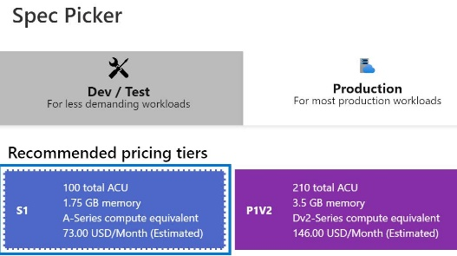

* + On the Basics page, select **Next : Deployment**.
  + On the Deployment page, in Continuous deployment, ensure that **Disable** is selected, and then select **Next : Networking (preview)**.
  + On the Networking (preview) page, in Enable network injection, ensure that **Off** is selected, and then select **Next : Monitoring**.
  + On the Monitoring page, in Enable Application Insights, ensure that **No** is selected.
  + Select **Review + create**, review the configuration, and then select **Create**.

You use an Azure [App Service](https://docs.microsoft.com/en-us/azure/app-service/overview) web app to host your website in the cloud in a fully managed environment. An [App Service plan](https://docs.microsoft.com/en-us/azure/app-service/overview-hosting-plans) defines the capacity and scalability of the web servers that support your website.

* In a new browser tab, go to the URL for the new web app at https://wa26435405.azurewebsites.net to verify that it is up and running.

You should see a default home page.

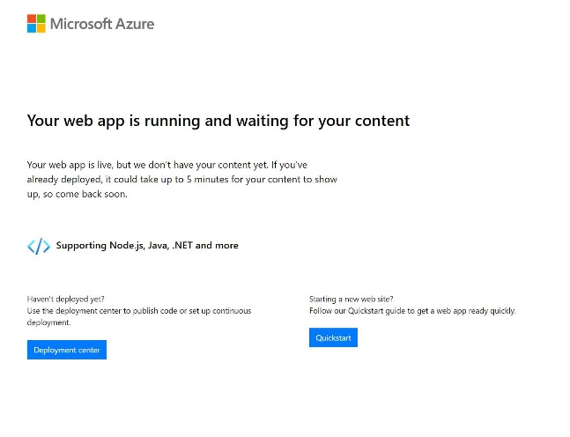

## Check your work

* Confirm that you created a web app named wa26435405.
* Confirm that you displayed the new web app in a browser.

# **Deploy application code**

* Deploy the source code for the **wa26435405** web app by using the values in the following table. For any property that is not specified, use the default value.

| **Property** | **Value** |
| --- | --- |
| Source | **External Git** |
| Repository | https://github.com/LODSContent/LODSOC\_app-service-web-dotnet-get-started |
| Branch | main |
| Repository Type | **Public** |

* Expand this hint for guidance on deploying the source code for a web app.
  + On the Azure portal home page, select **All resources**, and then select the **wa26435405** App Service.
  + On the wa26435405 resource menu, select **Deployment Center**.
  + On the Deployment Center page, select **Settings**.
  + In Source, select **External Git**, in Repository, enter https://github.com/LODSContent/LODSOC\_app-service-web-dotnet-get-started, in Branch, enter main, and then in Repository Type, ensure that **Public** is selected.

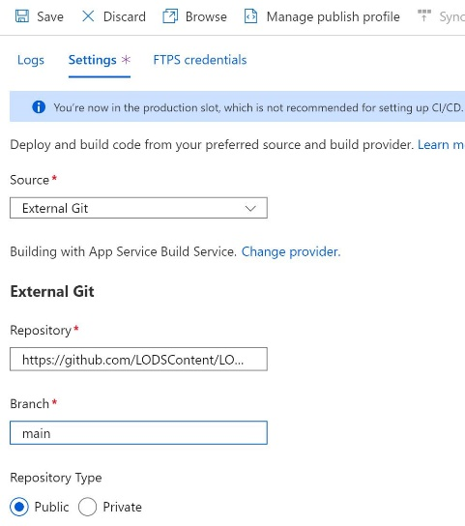

* + On the command bar, select **Save** to initiate the deployment.

You may have to wait 1–2 minutes for the new code to fully deploy.

* In a new browser tab, go to the URL for the new web app at https://wa26435405.azurewebsites.net to verify that it is up and running.

You should see an updated home page.

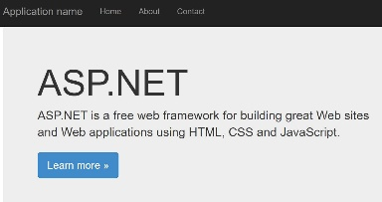

If you do not see the updated page, refresh the browser.

When you plan your deployment, make sure that you review the Azure App Service [deployment best practices](https://docs.microsoft.com/en-us/azure/app-service/deploy-best-practices" \o "Deployment Best Practices" \t "_blank) as part of your planning process.

## Check your work

* Confirm that you deployed the source code for the wa26435405 web app.
* Confirm that you tested the wa26435405 web app.

# **Enable Application Insights**

* Enable **Application Insights** for the wa26435405 web app by using the new resource name wa26435405 and the **laws-26435405** Log Analytics Worspace.

Expand this hint for guidance on enabling Application Insights.

* + On the wa26435405 resource menu, in Settings, select **Application Insights**.

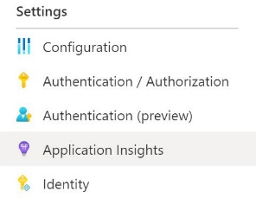

* + On the Application Insights page, select **Turn on Application Insights**.

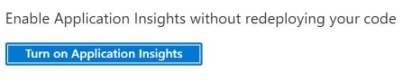

* + On the Application Insights page, in New resource name, ensure that the value is set to wa26435405.
  + In Log Analytics Workspace, select **laws-26435405 [eastus]** and then select **Apply**.
  + If prompted to Apply monitoring settings, select **Yes**.

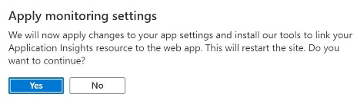

You may have to wait 1–2 minutes for Application Insights to be fully enabled.

Azure [Application Insights](https://docs.microsoft.com/en-us/azure/azure-monitor/app/app-insights-overview" \o "What is Application Insights?" \t "_blank) provides a set of reports and charts that you can use to monitor the key metrics and performance of your cloud apps.

* Open the **Live metrics** report on the **Application Dashboard**.

Expand this hint for guidance on opening the Live metrics report.

* + On the wa26435405 Application Insights page, select **View Applications Insights data**.

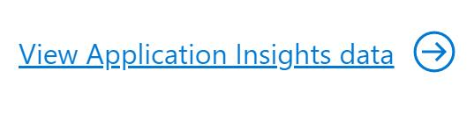

* + On the Application Insights page, on the command bar, select **Application Dashboard**.

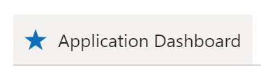

* + On the wa26435405 Dashboard page, select the **Live Stream** tile, and then wait for the Live metrics report to initialize.

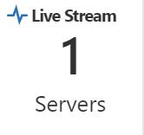

Keep the Live metrics report open to wait for future requests.

* In a new browser window, go to the URL for the web app at https://wa26435405.azurewebsites.net, and then refresh the browser a few times to generate valid requests.
* Generate a failed request for the web app by using the URL https://wa26435405.azurewebsites.net/default.
* Return to the **Live metrics** report to view the successful and failed requests.

You should see the successful and failed requests from the last 60 seconds.

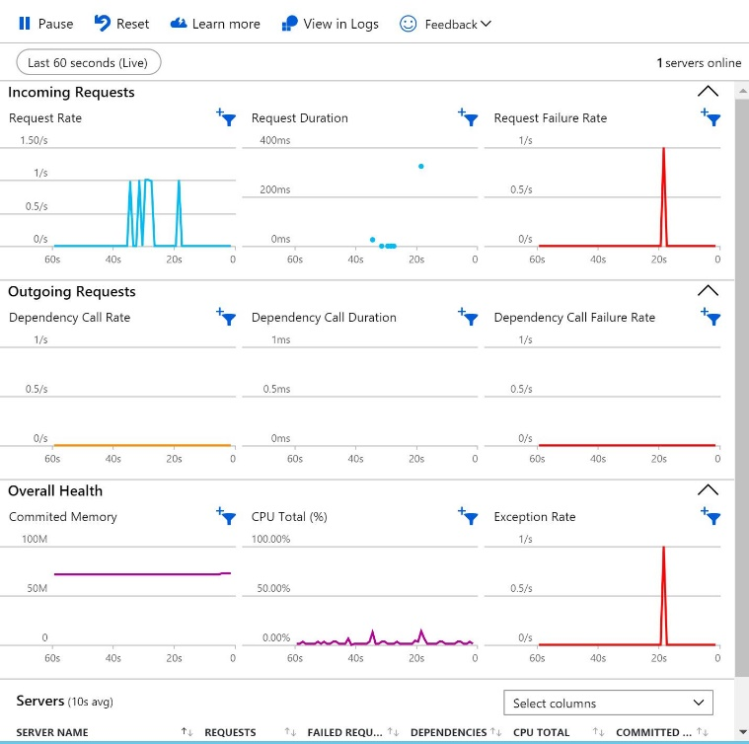

* On the **Application Dashboard**, open the **Failures** report , and then display the data from the **Last 30 minutes**.

Expand this hint for guidance on opening the Failures report on the Application Dashboard.

* + If necessary, close the **Live metrics** report.

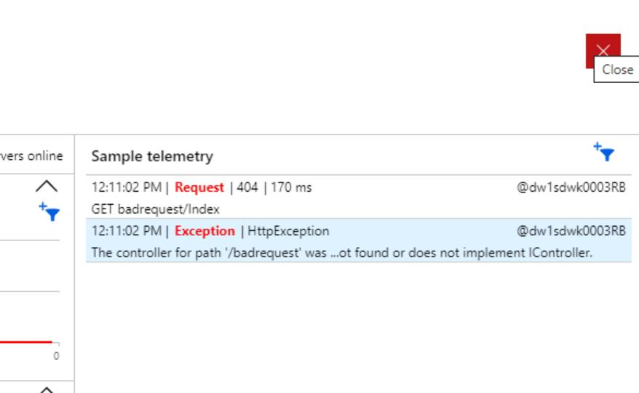

* + On the wa26435405 Dashboard page, select the **Failures** tile to open the Failures report.

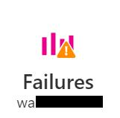

* + On the Failures report, select **Local Time: Last 24 hours**, in Time range, select **Last 30 minutes**, and then select **Apply**.

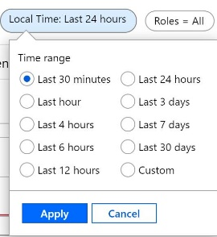

If you do not see the failed request, select Refresh. It may take 1–2 minutes for the latest failure to appear in the report.

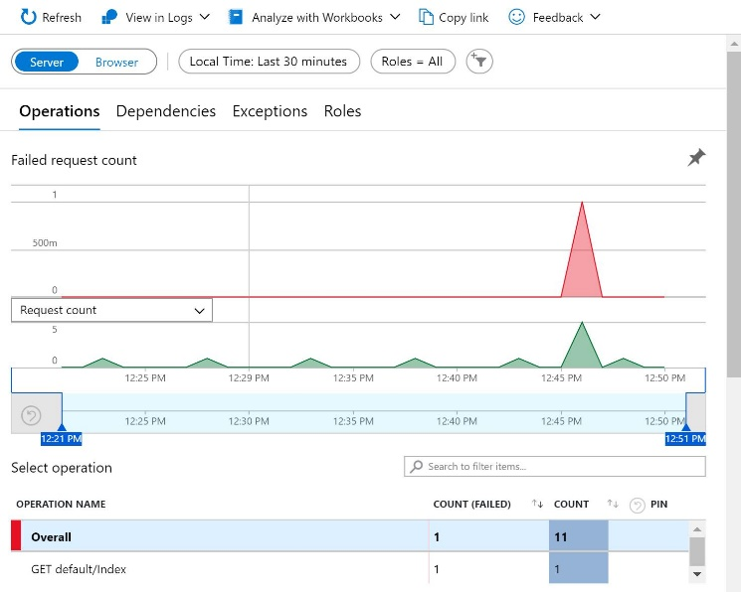

## Check your work

* Confirm that you enabled Application Insights.
* Confirm that you viewed requests in the Live metrics report on the Application Dashboard.
* Confirm that you displayed the Failures report on the Application Dashboard.

# **Enable App Service logs**

* Enable **App Service logs** for the wa26435405 web app by using the values in the following table. For any property that is not specified, use the default value.

| **Property** | **Value** |
| --- | --- |
| Application Logging (Filesystem) | **On** |
| Level | **Error** |
| Web server logging | **File System** |
| Quota (MB) | 35 |
| Retention Period (Days) | 90 |

* Expand this hint for guidance on enabling App Service logs.
  + On the Azure portal home page, select **All resources**, and then select the **wa26435405** App Service.
  + On the wa26435405 resource menu, in Monitoring, select **App Service logs**.
  + On the App Service logs page, in Application Logging (Filesystem), select **On**, in Level, ensure that **Error** is selected, in Web server logging, select **File System**, in Quota (MB), ensure that the value is set to 35, and then in Retention Period (Days), enter 90.

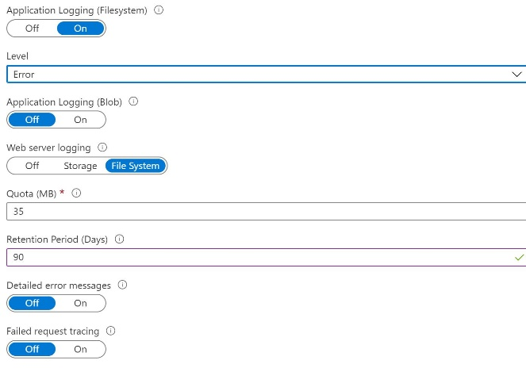

* + On the command bar, select **Save**.

You can use Azure [App Service logs](https://docs.microsoft.com/en-us/azure/app-service/troubleshoot-diagnostic-logs) to capture log messages that can help you to audit and debug your cloud apps.

* Open the **Log stream** for the wa26435405 web app.

Expand this hint for guidance on opening the Log stream for a web app.

* + On the wa26435405 resource menu, in Monitoring, select **Log stream**.
  + On the Log stream page, ensure that **Application logs** is selected, and then wait until the **Welcome, you are now connected to log-streaming service** message is displayed.

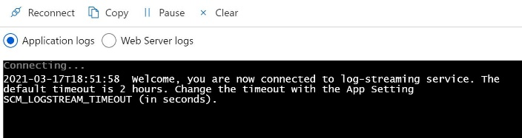

Keep the Log stream page open to wait for future requests.

* In a new browser window, go to the URL for the web app at https://wa26435405.azurewebsites.net to generate a valid request.
* Generate a failed request for the web app by using the URL https://wa26435405.azurewebsites.net/default.
* Return to the **Log stream** page, and then review the successful and failed requests.

You should see the requests appear in the Log stream within 60 seconds.

The successful request should display a return code of **200** and the failed request should display a return code of **404**.

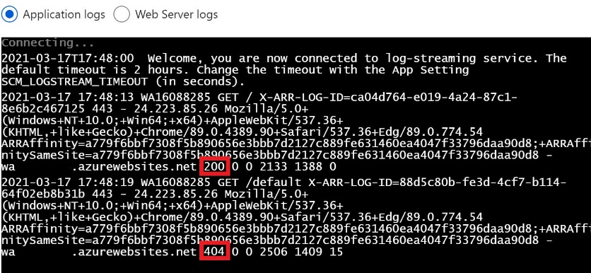

You may also see an AlwaysOn request appear in the Log stream. This is generated automatically every five minutes to prevent the web app from entering idle mode.

## Check your work

* Confirm that you enabled App Service logs.
* Confirm that you viewed requests on the Log stream page.

# **Summary**

Congratulations, you have completed the **Configure Application Insights and App Service Logs for a Web App** challenge.

You have accomplished the following:

* Created an Azure web app.
* Deployed application code.
* Enabled Application Insights.
* Enabled App Service logs.